**Video Surveillance System**

using





**A**

**PROJECT REPORT**

Submitted in partial fulfillment of the Requirements for the award of the degree of **BACHELOR OF TECHNOLOGY**

IN

**COMPUTER SCIENCE & ENGINEERING**

Specialization in

**Business Analytics and Optimization**

BY

**Name Roll No. SAPID**

ADESH KUMAR GUPTA R103216006 500053000

SHANKEY GUPTA R103216089 500054226

TUSHAR SINGH R103216109 500054191

UTKARSH SANDEEP SINGH R103216110 500053648

Under the guidance of

**Dr. Hitesh Kumar Sharma**

**AP(SG) and PIC**

**Department of Informatics**

School of Computer Science 

**University of Petroleum & Energy Studies** Bidholi, via Prem Nagar, Dehradun, UK

December 2019



**CANDIDATES DECLARATION**

We hereby certify that the project work entitled **Video Surveillance System** in partial fulfilment of the requirements for the award of the Degree of Bachelor of Technology in Computer Science And Engineering with Specialization in Business Analytics and Optimization and submitted to the Department of Informatics at School of Computer Science, University of Petroleum And Energy Studies, Dehradun, is an authentic record of our work carried out during a period from **September, 2019 to December, 2019** under the supervision of **Dr Hitesh Kumar Sharma**, **AP & PIC.**

The matter presented in this project has not been submitted by us for the award of any other degree of this or any other University.

**(Name of Student(s))**

Adesh, Shankey, Tushar, Utkarsh

**Roll No.**

R103216006, R103216089, R103216109, R103216110

This is to certify that the above statement made by the candidate is correct to the best of my knowledge.

(Date: 13 December 2019) (Name of Guide)

Project Guide

Dr. T.P Singh

Head

Department of Informatics

School of Computer Science

University of Petroleum And Energy Studies

Dehradun - 248 001 (Uttarakhand)

**ACKNOWLEDGEMENT**

We wish to express our deep gratitude to our guide Name, for all advice, encouragement and constant support he has given us throughout our project work. This work would not have been possible without his support and valuable suggestions.

We sincerely thank to our Head of the Department, Dr. T.P Singh, for his great support in doing our project name at SoCS.

We are also grateful to Dr. Manish Prateek Professor and Director SoCS, UPES for giving us the necessary facilities to carry out our project work successfully.

We would like to thank all our friends for their help and constructive criticism during our project work. Finally we have no words to express our sincere gratitude to our parents who have shown us this world and for every support they have given us.

Name Adesh Shankey Tushar Utkarsh

Roll No. R103216006 R103216089 R103216109 R103216110

**Abstract**

Security is one of the major concerns in today's world for everyone. People are very much concerned about it and take the best possible measures to ensure it. Many people be it for their household or for their work organization use the traditional technology of CCTV cameras which record videos for days and months and if any mis happenings take place, they check their CCTV recordings and look for the possible evidences that caused it, but the mishappening has already taken place and damage is already done.

In order to overcome this problem and prevent any mis happenings from taking place we are coming up with an enhanced version of this traditional technology that is a “Video Surveillance System” which will detect any unusual activity and based on it will send a prompt via an SMS or mail to the user for which the user can take appropriate action before the damage being done.

In this way the problems that soldiers face on the border can be avoided and if any unknown human being is detected, instant prompt will be sent and the army people can take sudden action against it and avoid any kind of damage from happening. This will act as a much better solution as there won't be any need to analyse everything again from the past recordings of a CCTV camera after taking place of an unwanted activity. This will help to reduce man power and will be a good safety approach for property and life

**TABLE OF CONTENTS**

**Contents**

1. Introduction 6
2. Problem Statement 6
3. Literature Review 6
4. Objective 7
5. Design 8
   1. Flowchart
6. Methodology 9
   1. Theory 9
   2. Approach 9
7. Implementation 9
   1. Algorithm 9

7.2 Output 9

1. System Requirements 12
2. Conclusion and Future Scope 12
3. Schedule (PERT Chart) 12
4. Reference 13

Appendix A Project Code

1. **Introduction:**

We know surveillance is very important and necessary in today's world. Be it safety of people or safety of precious things surveillance plays a huge role in security purposes. The more important the surveillance of human beings is, the equal it is for other tasks like watching over valuables, monitoring operations, employee safety, loss prevention and public safety.

Video Surveillance System is a great answer to all these issues to maintain an even stronger and reliable level of security. It is a model based on deep learning which is able to detect the right objects in live video almost all of the time. This system would be capable of capturing images and videos to find out any unusual activities. This system proves to be an enhanced version of the traditional surveillance systems that were used for security purposes.

Traditional systems continuously recorded and saved video footages for days and months which utilized a lot of battery and storage capacity to store these large video footage, but this  
enhanced Surveillance System will continuously monitor but would record only any unusual changes that happen during its monitoring like theft detection, fire detection.  
As soon as the system catches any unusual activity it immediately takes a step against it and informs the user by sending an SMS or an Image via E-Mail.

1. **Problem Statement:**

As we all know, for the security purposes, CCTV cameras are installed everywhere but the main problem is that it requires 24X7 human monitoring that is not feasible and also if any happening occurs then it doesn’t send us any alert signals. We can only check manually the previously recorded data. That results in huge loss of life, money and property.

1. **Literature Review:**

[1] The process of analyzing video sequence is termed as Video Surveillance. Video Surveillance activities can be categorized into 3 types manual, semi-autonomous and fully-autonomous. In fully-autonomous video is taken only is the scene where surveillance is need to be performed. Automatic motion detection which can get better human attention.

[2] Foundation subtraction techniques are generally abused for moving item recognition in recordings in numerous applications, for example, traffic observing, human movement catch, and video surveillance. Step by step instructions to effectively and proficiently model and update the foundation model and how to manage shadows are two of the most recognizing and testing parts of such approaches. The article proposes a broadly useful strategy that joins factual suspicions with the item level information of moving items, clear questions (apparitions), and shadows obtained in the handling of the past casings.

[3] A Bayes choice principle for the arrangement of foundation and the closer view from chosen include vectors is planned. Under this standard, various kinds of foundation items will be arranged from frontal area protests by picking a legitimate component vector. The stationary foundation item is depicted by the shading highlight, and the moving foundation article is spoken to by the shading co-event include. Forefront articles are extricated by melding the arrangement results from both stationary and moving pixels.

[4] Surveillance is a vital piece of security and is utilized everywhere throughout the world to guarantee the wellbeing of resources just as individuals. Despite the fact that surveillance is dubious in certain circumstances. Particularly when associated with surveillance of people it is vital for different errands like looking out for assets, observing tasks, guaranteeing representative wellbeing just as misfortune counteractive action and open security. The TensorFlow Object Detection API is an open-source system that enables you to utilize pre-prepared article location models or make and train new models by utilizing move learning. This is amazingly helpful on the grounds that building an article discovery model without any preparation can be troublesome and can set aside an exceptionally long effort to prepare.

1. **Objectives:**
2. To train our model with the different objects.
3. To identify the objects from the live video streaming.
4. To send the alert signal in the form of emails, messages, light or sound.
5. **Design**

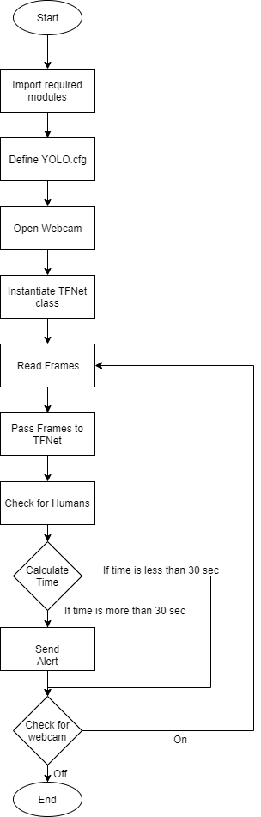

Diagram: Flow chart for Video Surveillance System

1. **Methodology:**
   1. **Theory:**

This project is about automating the surveillance system which will send alerts in

case of any unusual activity.

1. **Object Training and Object Identification**

For the implementation of this technique, we will use some python modules:

**OpenCV:** To use computer camera as video capturing device and for image processing.

**DarkFlow:** To use TensorFlow TFNet module for Object Detection.

1. **Alert through Mail**

We are using SMTP protocol for alerting via Mail whenever it will receive any unwanted activity on the camera it will send an alert signal to the respective authorities.

* 1. **Approach:**

1. **Object Training and Object Identification**
2. Importing specified modules
3. Define options to build the model. We are using yolo.cfg model.
4. Capture live video through webcam
5. Instantiate TFNet class with options.
6. Read frames from video until webcam is on.
7. Pass these frames into TFNet predict function which will return results containing object label, top left & bottom right coordinates and confidence for each object.
8. For each object:
   1. Extract top left & bottom right coordinates
   2. Store the label
   3. Draw rectangle box around that object and specify label
9. Show these frames until webcam is on.
10. In case of border surveillance, if label is human an alert will be generated.
    1. Similarly, based on different parameters (predefined) we can generate alerts.
11. **Alert through Mail**
    1. Import required libraries for smtp protocol
    2. Create server connection with Gmail by respective port no.
    3. Provide login details of sender
    4. Provide details of sender and receiver along with the message to be passed
    5. Terminate the connection
12. **Implementation**
    1. **Algorithm**

Steps for Algorithm:

Step 1: Start

Step 2: Import numpy, cv2 and tensorflow module

Step 3: Import Time and SMTP module

Step 4: Open WebCam

Step 5: Check for person in front of WebCam

Step 6: Calculate time Starting from person Standing

Step 7: If time is more than 30 sec

Step 8: Send the alert mail to administrator

Step 9: Otherwise Ignore

Step 10: End

* 1. **Output Screen**

**7.2.1 Object Detection & Identification**

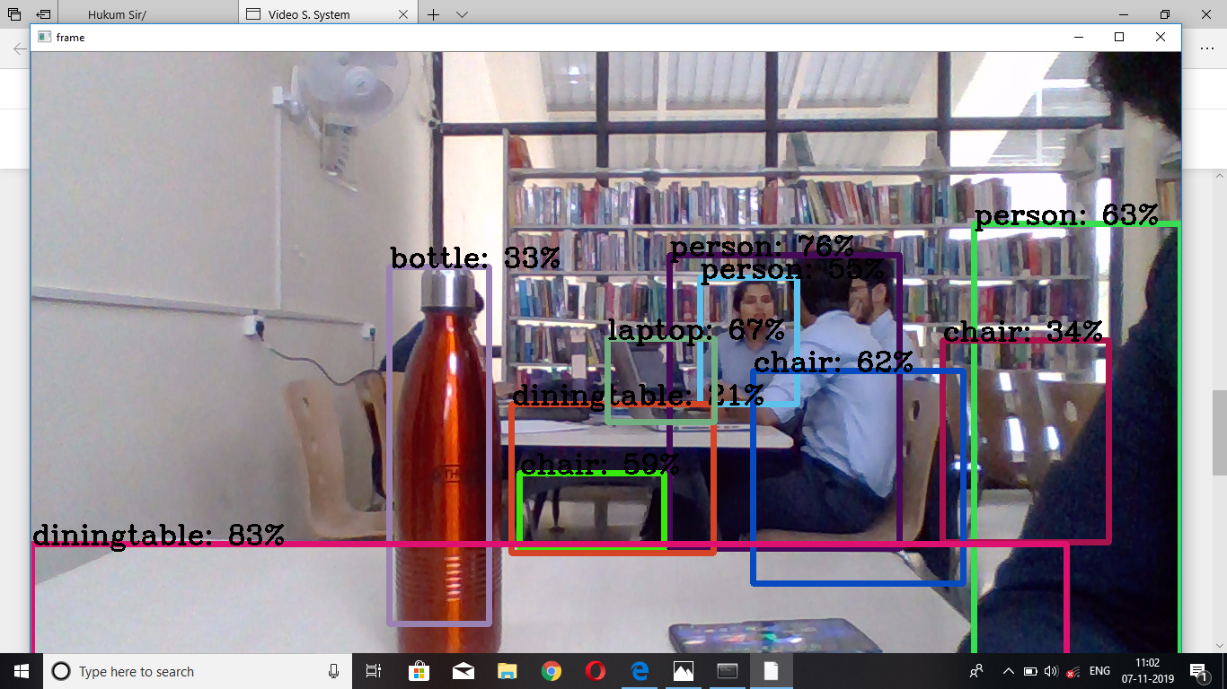

Output 1

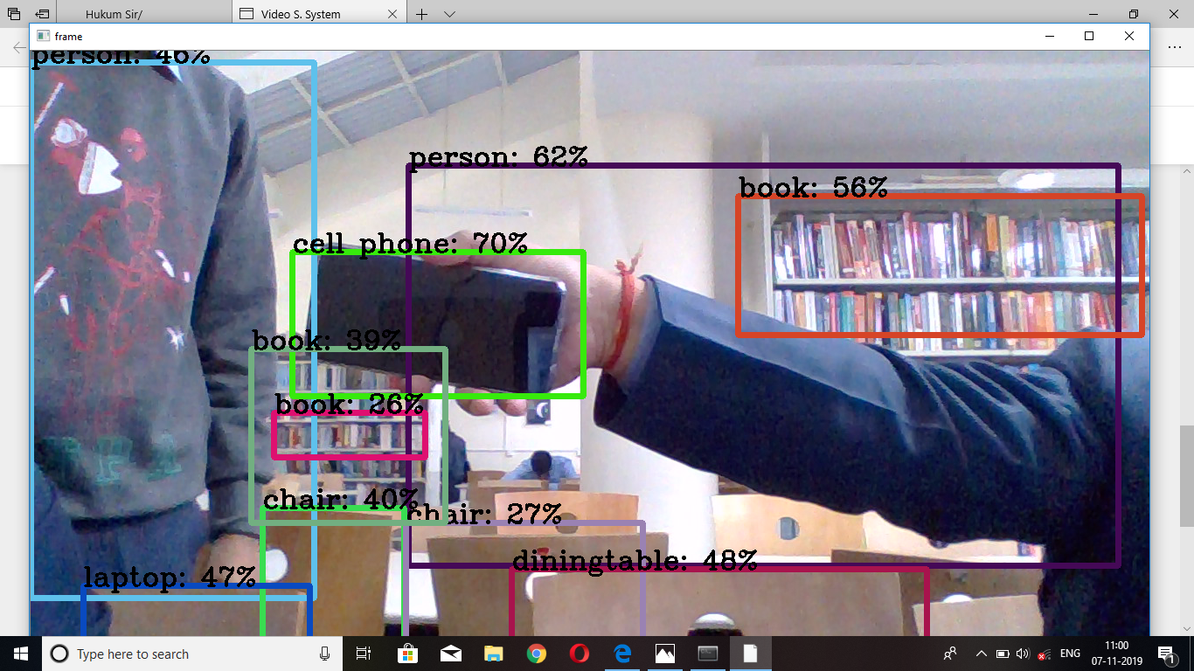

Output 2

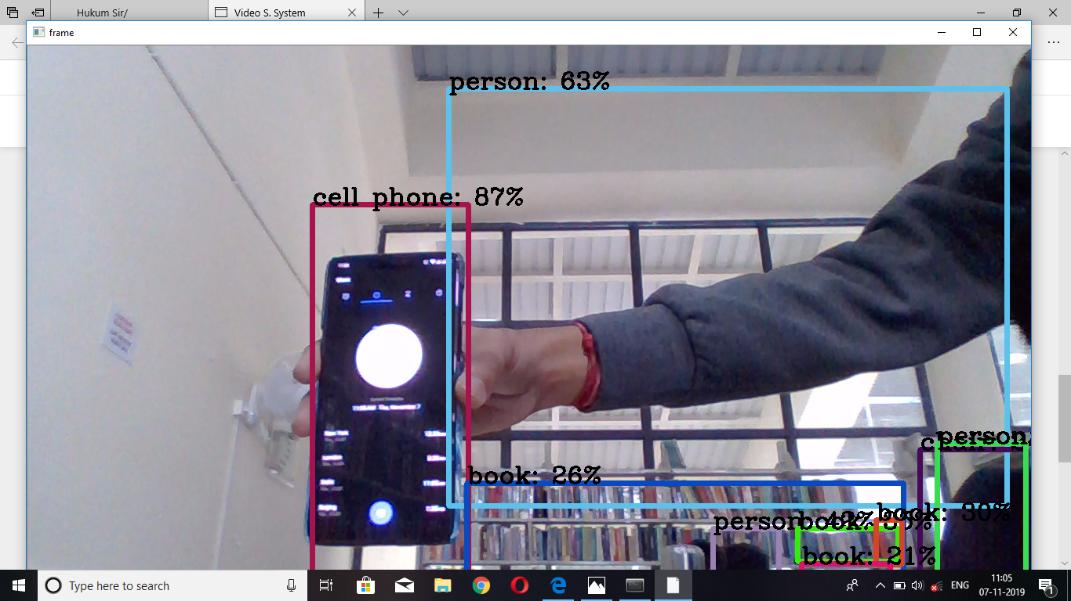

Output 3

* + 1. **Alert Mail**
       1. **Receiver**

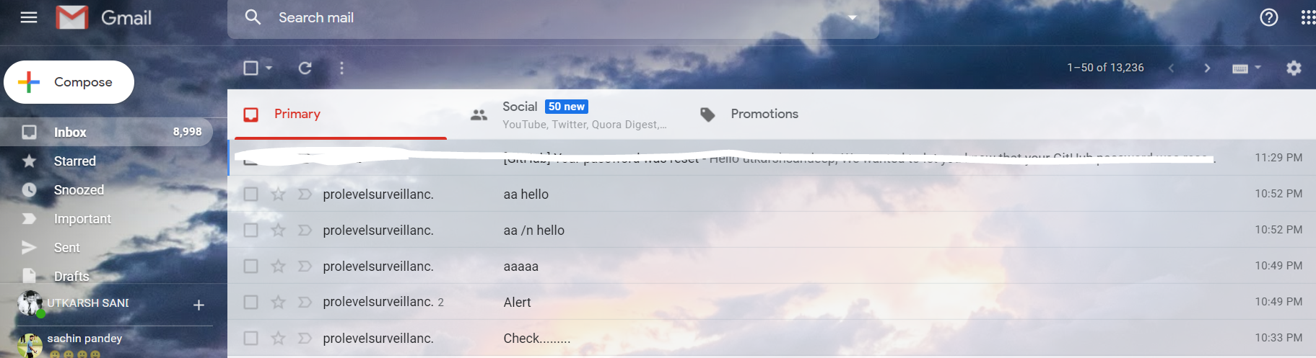

* + - 1. **Sender**

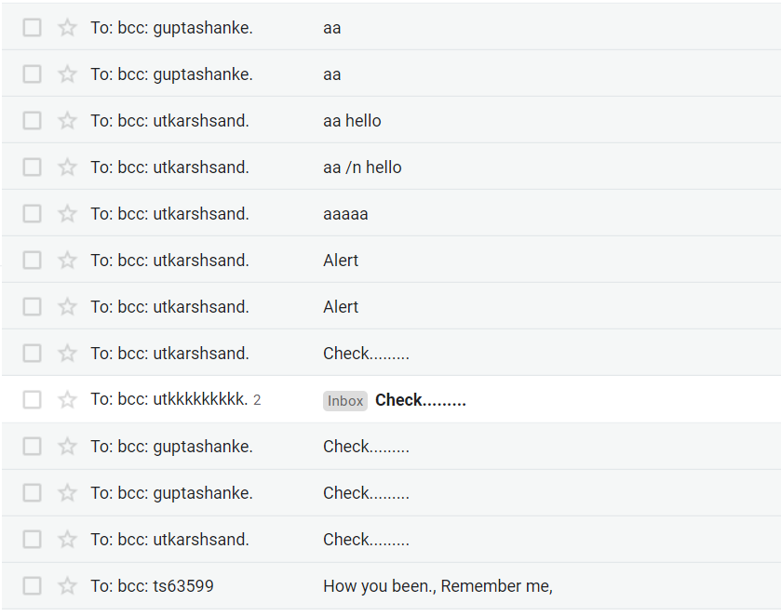

**8. System Requirements: (Software/Hardware)**

**Hardware:**

RAM- 8GB

Processors- Intel Core i3/i5/i7

HDD- 2GB

**Software:**

Operating System- Windows 10/8.1/8/7/XP | Ubuntu| RedHat

Programming Language- Python

* + 1. **Conclusion and Future Scope**

By using the model of Video Surveillance, we were able to identify different objects successfully. This model is suitable for application in Defense or Border side where in case if an unknown person keeps standing in front of the camera for more than a specified time limit i.e. for more than 20-30 secs, then the system is able to detect it as an unusual activity and based on it sends an alert mail to the user or admin to take compulsory actions.

The future scope of this System is that it can be applied to different areas and domains like societies, unrestricted areas etc. and on the basis of field it has to be used for some certain modifications will be needed to be done but the concept of the model remains the same.

* + 1. **Schedule: (PERT Chart)**

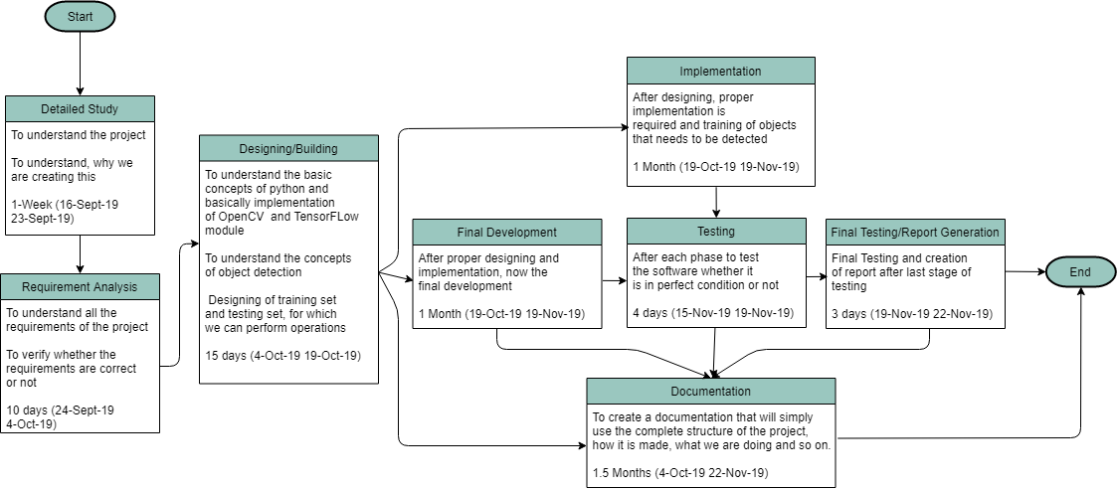

**Fig 1.1 Pert Chart**

* + 1. **References:**

Documented Reference:

[1] A Survey on Moving Object Detection and Tracking in Video Surveillance System <http://citeseerx.ist.psu.edu/viewdoc/download?doi=10.1.1.645.7492&rep=rep1&type=pdf>

# [2] Detecting moving objects, ghosts, and shadows in video streams

<https://ieeexplore.ieee.org/abstract/document/1233909>

# [3] Foreground object detection from videos containing complex background

# <https://dl.acm.org/citation.cfm?id=957017>

# [4] Simple Surveillance System with the TensorFlow Object Detection API

# <https://towardsdatascience.com/simple-surveillance-system-with-the-tensorflow-object-detection-api-125e04d36446>

**Appendix Project Code**

import cv2

import numpy as np

import time

from darkflow.net.build import TFNet

import smtplib

#create object in this case we User GMAIL , 587 is Gmail.

smtpObj = smtplib.SMTP('smtp.gmail.com', 587)

#Encryption.

smtpObj.starttls()

#Time to login to your email, then enter your password.

smtpObj.login('prolevelsurveillance007@gmail.com', 'xyz@12345')

import os

os.chdir('D:\YOLO REPO\darkflow-master')

options = {

'model': 'cfg/yolo.cfg',

'load': 'bin/yolo.weights',

'threshold': 0.2,

'gpu': 1.0

}

tfnet = TFNet(options)

colors = [tuple(255 * np.random.rand(3)) for _ in range(10)]

capture = cv2.VideoCapture(0)

capture.set(cv2.CAP_PROP_FRAME_WIDTH, 1920)

capture.set(cv2.CAP_PROP_FRAME_HEIGHT, 1080)

flag = 0

while True:

stime = time.time()

ret, frame = capture.read()

check = 0

if ret:

results = tfnet.return_predict(frame)

for result in results:

label = result['label']

if(label == 'person'):

check = 1

break

if(check == 0):

#p_stime = 0

flag = 0

for color, result in zip(colors, results):

tl = (result['topleft']['x'], result['topleft']['y'])

br = (result['bottomright']['x'], result['bottomright']['y'])

label = result['label']

if(label == 'person' and flag == 0):

p_stime = time.time()

flag = 1

if(flag == 1 and label == 'person' and time.time() - p_stime > 20 ):

smtpObj.sendmail('prolevelsurveillance007@gmail.com','500054226@stu.upes.ac.in','Subject: alert!!!!!!!')

flag = 0

confidence = result['confidence']

text = '{}: {:.0f}%'.format(label, confidence * 100)

frame = cv2.rectangle(frame, tl, br, color, 5)

frame = cv2.putText(

frame, text, tl, cv2.FONT_HERSHEY_COMPLEX, 1, (0, 0, 0), 2)

cv2.imshow('frame', frame)

print('FPS {:.1f}'.format(1 / (time.time() - stime)))

if cv2.waitKey(1) & 0xFF == ord('q'):

break

smtpObj.quit()

capture.release()

cv2.destroyAllWindows()